Azur Active Directory Client Id and Client Secret

Step - 1 : Login to office 365 Admin user https://www.office.com/signin
Step - 2 : Click on Admin Menu
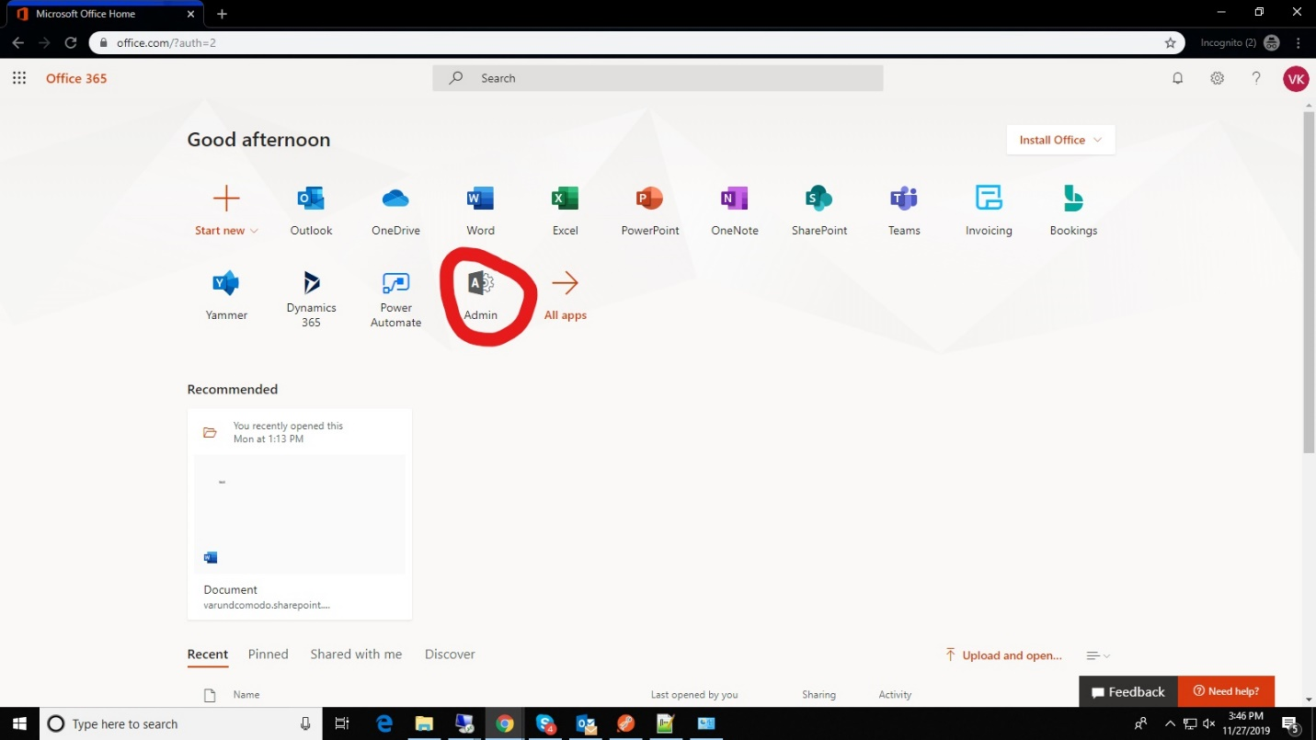

Step - 3: Click Show All and select Azure Active directory in the left column

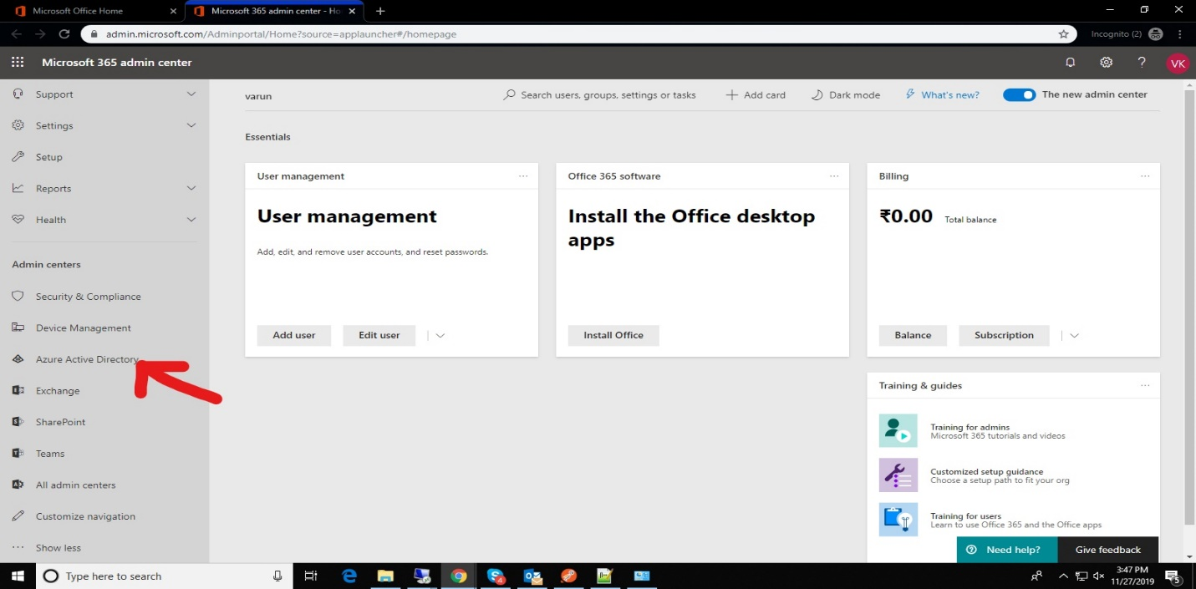
Step - 4 : Click Azure Active directory in the left column

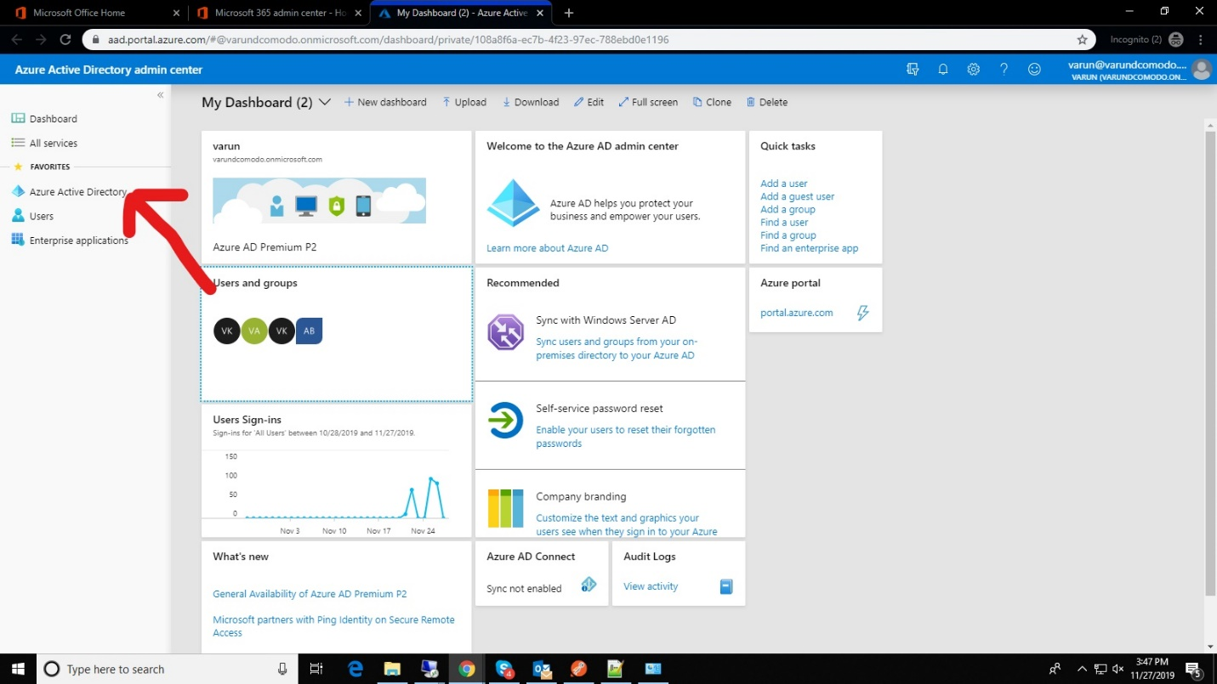

Step - 5: Here Already have an app go for it, else create new one.

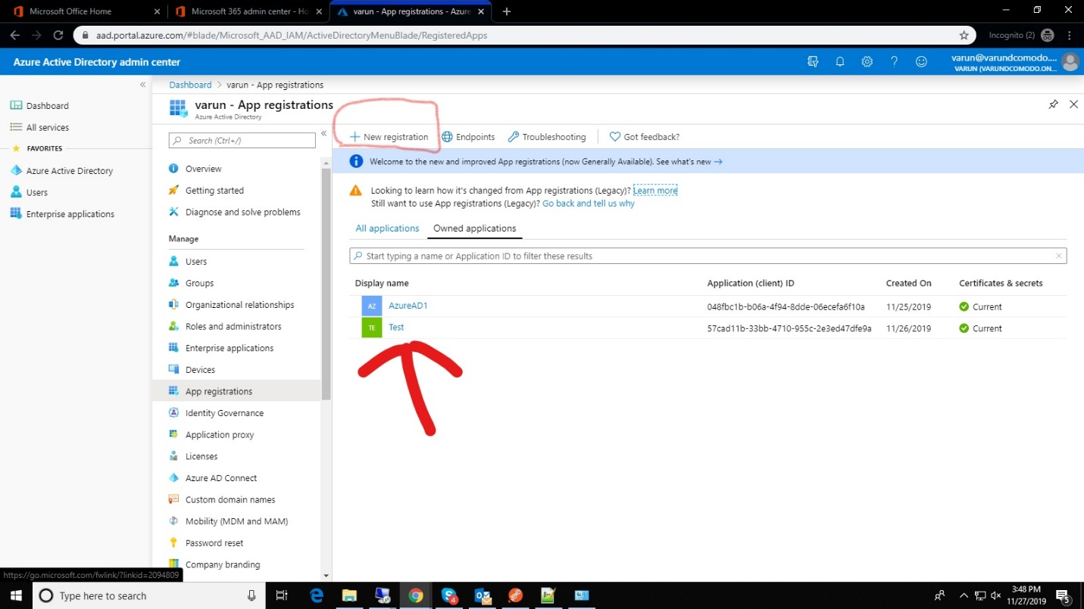

Step - 6: Here you get the Client Id

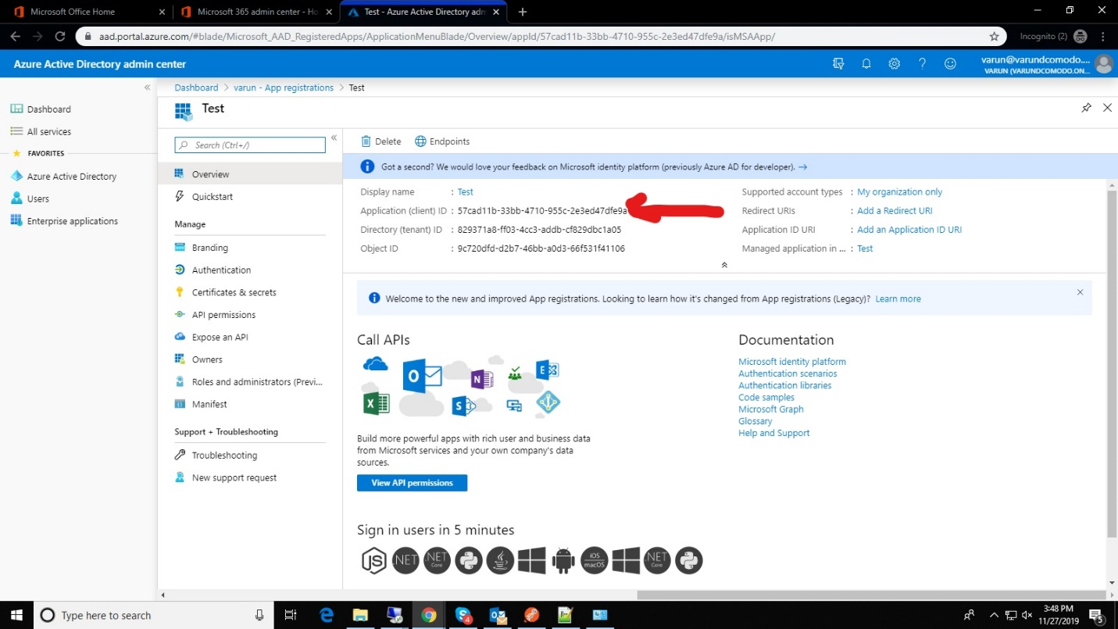

Step - 7: Here note the Client Secret

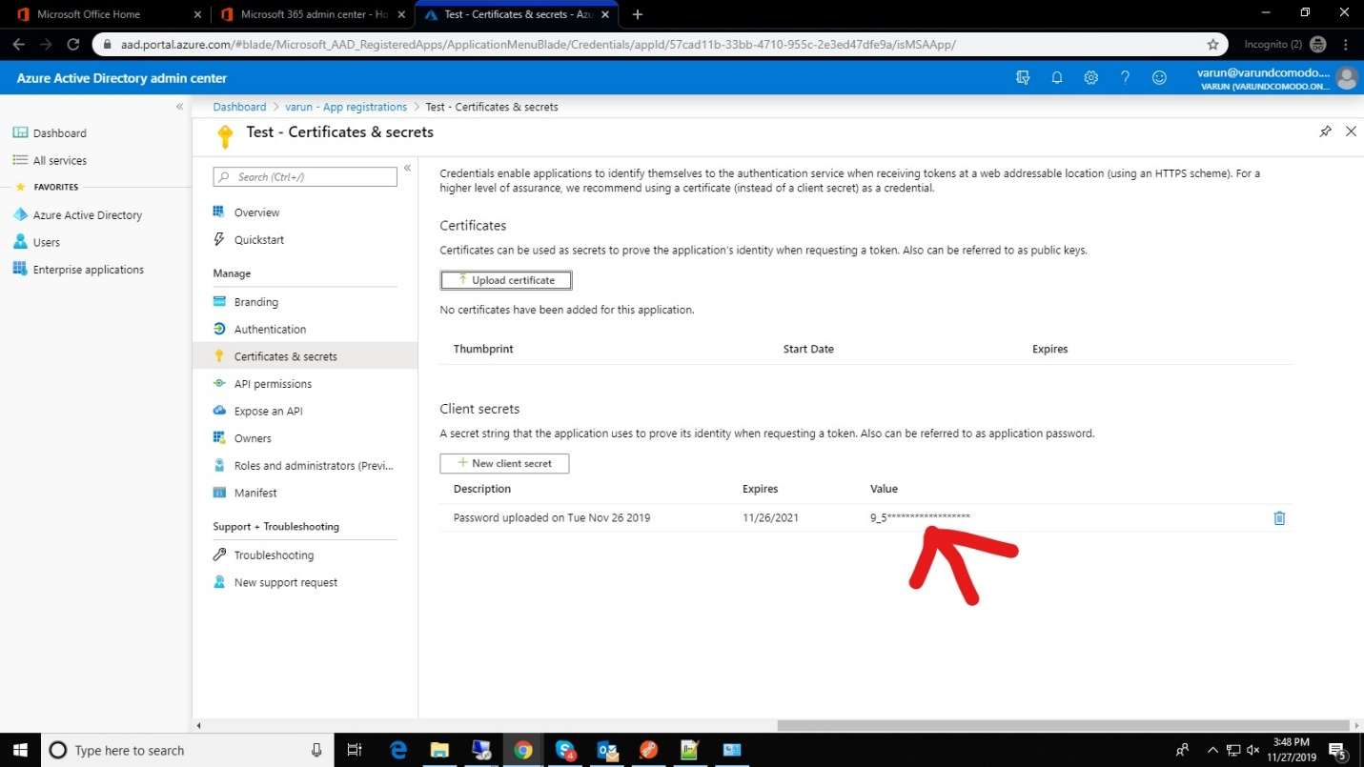

Step - 8 : Finally to give the permission for app
Click App permissions → Microsoft Graph → Deligated Permissions → select all Files and User permissions

Click App permissions → Microsoft Graph → Application Permissions → select all Files and User permissions
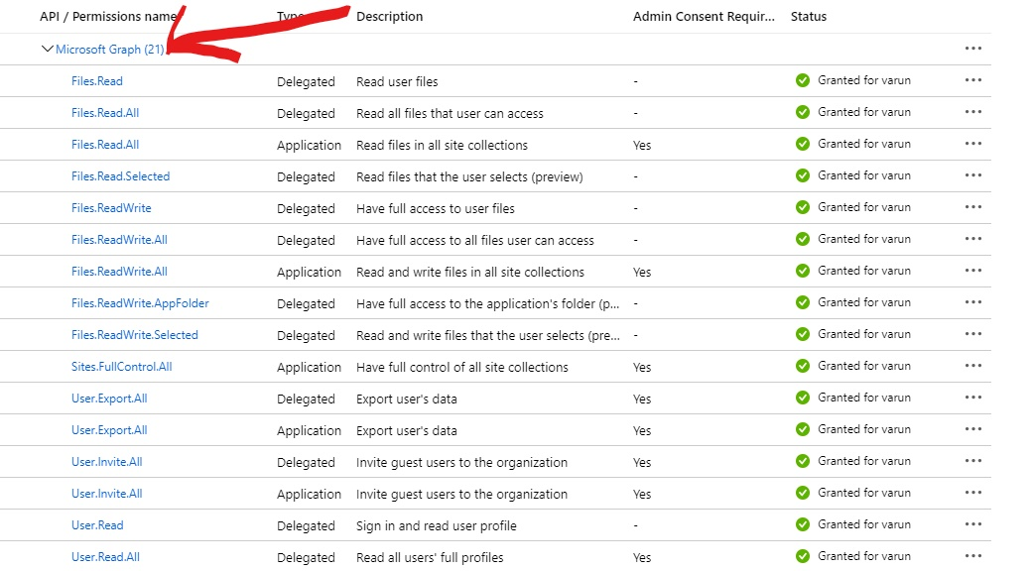

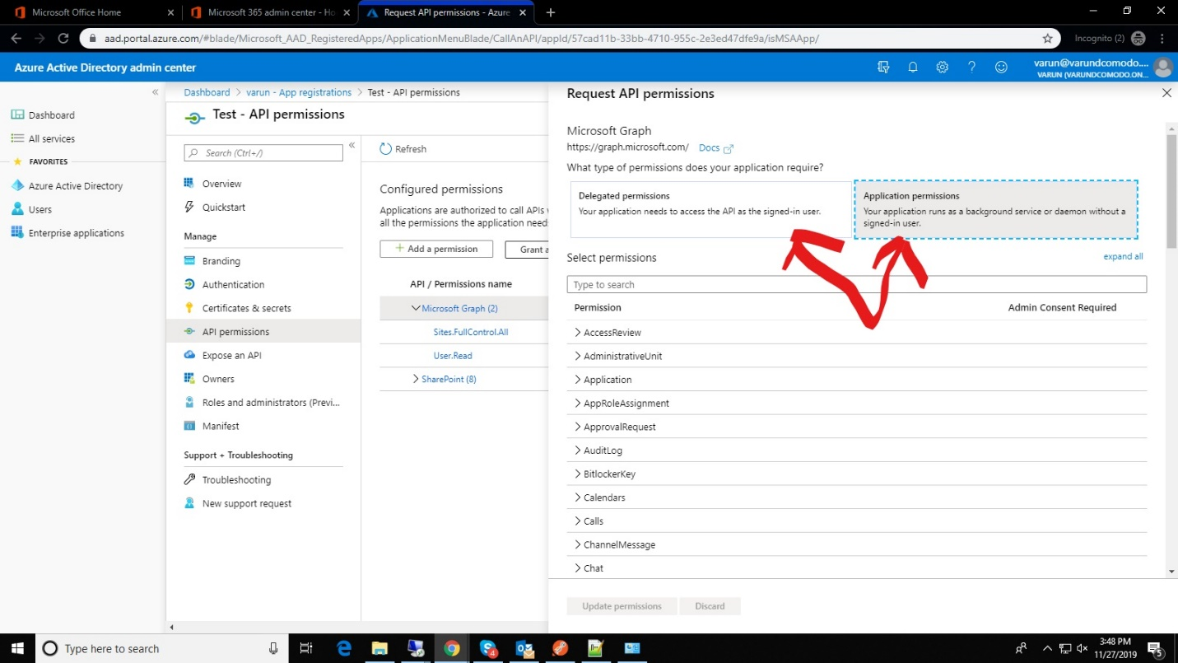
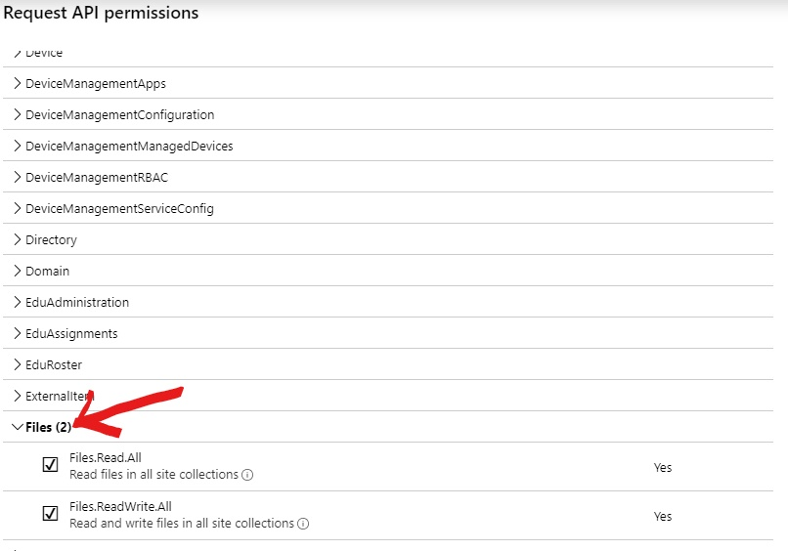

To check its Granted or not( Its take some time to grant otherwise click admin grant)

